# Name: Apurba Koirala

# Reg no: 22BCE3799

# Subject Code: BCSE204P

# Course Title: Design and Analysis of Algorithms Lab

# Lab Slot: L39 + L40

# Guided by: Dr. IYAPPAN P

# Lab Assessment 4

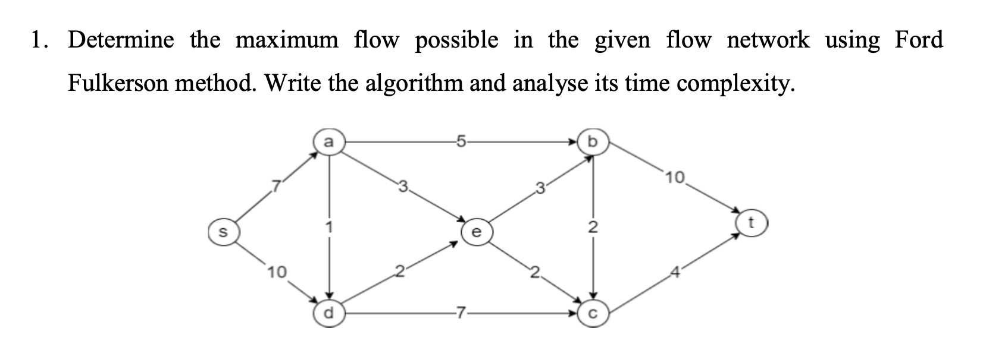

Algorithm:

1. Function BFS(rGraph, source, sink, parent):

- Initialize visited array as false.

- Create a queue, enqueue source, mark it visited.

- While queue is not empty:

- Dequeue a node and explore its neighbors.

- If an unvisited neighbor has positive capacity, enqueue it, mark visited, and store parent.

- Return true if sink is reached, otherwise false.

2. Function FordFulkerson(graph, source, sink):

- Create a residual graph rGraph initialized as graph.

- Initialize max_flow = 0.

- While there exists an augmenting path (using BFS):

- Find the minimum residual capacity along the path.

- Update residual capacities along the path.

- Add path flow to max_flow.

- Return max_flow.

3. Main function:

- Define the capacity graph as a 7x7 matrix.

- Call FordFulkerson(graph, source=0, sink=6).

- Print the maximum possible flow.

Code

#include <iostream>

#include <climits>

#include <queue>

#include <string.h>

using namespace std;

bool bfs(int rGraph[][7], int s, int t, int parent[]) {

bool visited[7];

memset(visited, 0, sizeof(visited));

queue<int> q;

q.push(s);

visited[s] = true;

parent[s] = -1;

while (!q.empty()) {

int u = q.front();

q.pop();

for (int v = 0; v < 7; v++) {

if (!visited[v] && rGraph[u][v] > 0) {

q.push(v);

parent[v] = u;

visited[v] = true;

}

}

}

return visited[t];

}

int fordFulkerson(int graph[7][7], int s, int t) {

int u, v;

int rGraph[7][7];

for (u = 0; u < 7; u++)

for (v = 0; v < 7; v++)

rGraph[u][v] = graph[u][v];

int parent[7];

int max_flow = 0;

while (bfs(rGraph, s, t, parent)) {

int path_flow = INT_MAX;

for (v = t; v != s; v = parent[v]) {

u = parent[v];

path_flow = min(path_flow, rGraph[u][v]);

}

for (v = t; v != s; v = parent[v]) {

u = parent[v];

rGraph[u][v] -= path_flow;

rGraph[v][u] += path_flow;

}

max_flow += path_flow;

}

return max_flow;

}

int main() {

int graph[7][7] = { {0, 7, 0, 0, 10, 0, 0},

{0, 0, 5, 0, 1, 3, 0},

{0, 0, 0, 2, 0, 0, 10},

{0, 0, 0, 0, 0, 0, 4},

{0, 0, 0, 7, 0, 2, 0},

{0, 0, 3, 2, 0, 0, 0},

{0, 0, 0, 0, 0, 0, 0} };

cout << "The maximum possible flow is " << fordFulkerson(graph, 0, 6)<<endl;

return 0;

}

Input:

int graph[7][7] = { {0, 7, 0, 0, 10, 0, 0},

{0, 0, 5, 0, 1, 3, 0},

{0, 0, 0, 2, 0, 0, 10},

{0, 0, 0, 0, 0, 0, 4},

{0, 0, 0, 7, 0, 2, 0},

{0, 0, 3, 2, 0, 0, 0},

{0, 0, 0, 0, 0, 0, 0} };

Output:

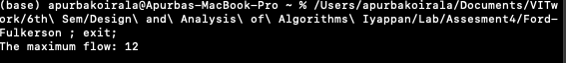

Time Complexity analysis

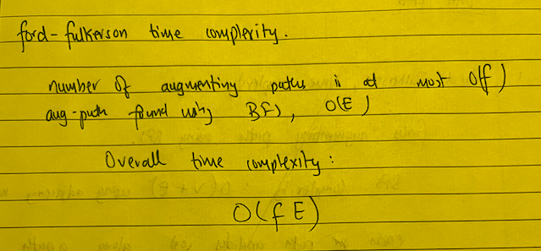

Algorithm:

Function EdmondsKarp(graph, source, sink):

maxFlow = 0

While there exists a path from source to sink in residualGraph using BFS:

pathFlow = min(residual capacity along the path)

For each edge (u, v) in the found path:

residualGraph[u][v] -= pathFlow

residualGraph[v][u] += pathFlow

maxFlow += pathFlow

Return maxflow

Code:

#include<cstdio>

#include<queue>

#include<cstring>

#include<vector>

#include<iostream>

using namespace std;

int c[10][10];

int flowPassed[10][10];

vector<int> g[10];

int parList[10];

int currentPathC[10];

int bfs(int sNode, int eNode)

{

memset(parList, -1, sizeof(parList));

memset(currentPathC, 0, sizeof(currentPathC));

queue<int> q;

q.push(sNode);

parList[sNode] = -1;

currentPathC[sNode] = 999;

while(!q.empty())

{

int currNode = q.front();

q.pop();

for(int i=0; i<g[currNode].size(); i++)

{

int to = g[currNode][i];

if(parList[to] == -1)

{

if(c[currNode][to] - flowPassed[currNode][to] > 0)

{

parList[to] = currNode;

currentPathC[to] = min(currentPathC[currNode],

c[currNode][to] - flowPassed[currNode][to]);

if(to == eNode)

{

return currentPathC[eNode];

}

q.push(to);

}

}

}

}

return 0;

}

int edmondsKarp(int sNode, int eNode)

{

int maxFlow = 0;

while(true)

{

int flow = bfs(sNode, eNode);

if (flow == 0)

{

break;

}

maxFlow += flow;

int currNode = eNode;

while(currNode != sNode)

{

int prevNode = parList[currNode];

flowPassed[prevNode][currNode] += flow;

flowPassed[currNode][prevNode] -= flow;

currNode = prevNode;

}

}

return maxFlow;

}

int main()

{

int nodCount, edCount;

cout<<"enter the number of nodes and edges\n";

cin>>nodCount>>edCount;

int source, sink;

cout<<"enter the source and sink\n";

cin>>source>>sink;

for(int ed = 0; ed < edCount; ed++)

{

cout<<"enter the start and end vertex along with capacity\n";

int from, to, cap;

cin>>from>>to>>cap;

c[from][to] = cap;

g[from].push_back(to);

g[to].push_back(from);

}

int maxFlow = edmondsKarp(source, sink);

cout<<endl<<endl<<"Max Flow is:"<<maxFlow<<endl;

}

Input

Output



Time complexity analysis

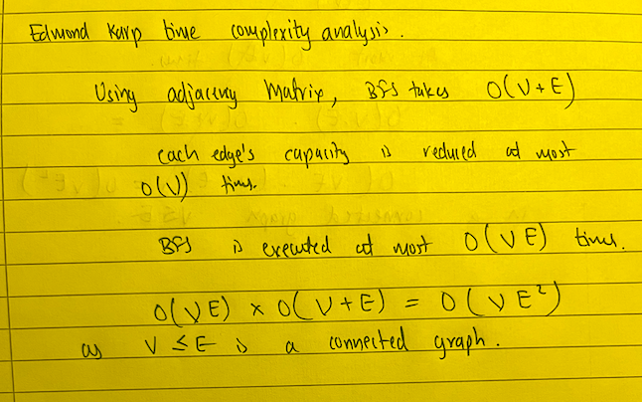

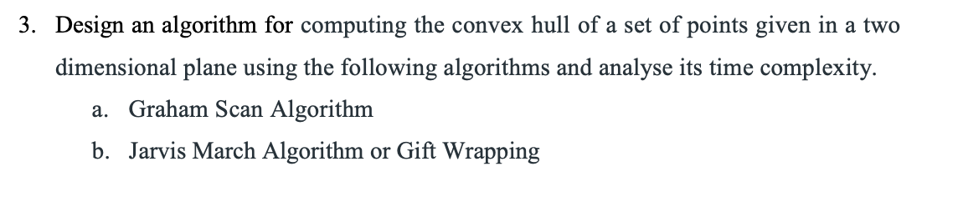

Graham Scan

Algorithm

FUNCTION convexHullGS(points[], n):

Find the point with the smallest y-coordinate (leftmost if tie), set as p0

Sort points by polar angle with p0 (using orientation and distance)

Initialize an empty stack S

Push first three points onto S

FOR i FROM 3 TO n-1:

WHILE orientation(nextToTop(S), S.top(), points[i]) != counterclockwise:

Pop from S

Push points[i] onto S

WHILE S is not empty:

Print and pop points from S

Code:

#include <iostream>

#include <stack>

#include <stdlib.h>

using namespace std;

struct Point {

int x;

int y;

};

Point p0;

Point nextToTop(stack<Point> &S) {

Point p = S.top();

S.pop();

Point res = S.top();

S.push(p);

return res;

}

void swap(Point &p1, Point &p2) {

Point temp = p1;

p1 = p2;

p2 = temp;

}

int dist(Point p1, Point p2) {

return (p1.x - p2.x) * (p1.x - p2.x) + (p1.y - p2.y) * (p1.y - p2.y);

}

int orientation(Point p, Point q, Point r) {

int val = (q.y - p.y) * (r.x - q.x) - (q.x - p.x) * (r.y - q.y);

if (val == 0) return 0;

return (val > 0) ? 1 : 2;

}

int compare(const void *vp1, const void *vp2) {

Point *p1 = (Point *) vp1;

Point *p2 = (Point *) vp2;

int o = orientation(p0, *p1, *p2);

if (o == 0)

return (dist(p0, *p2) >= dist(p0, *p1)) ? -1 : 1;

return (o == 2) ? -1 : 1;

}

void convexHull(Point points[], int n) {

int ymin = points[0].y, min = 0;

for (int i = 1; i < n; i++) {

int y = points[i].y;

if ((y < ymin) || (ymin == y && points[i].x < points[min].x))

ymin = points[i].y, min = i;

}

swap(points[0], points[min]);

p0 = points[0];

qsort(&points[1], n - 1, sizeof(Point), compare);

stack<Point> S;

S.push(points[0]);

S.push(points[1]);

S.push(points[2]);

for (int i = 3; i < n; i++) {

while (orientation(nextToTop(S), S.top(), points[i]) != 2)

S.pop();

S.push(points[i]);

}

while (!S.empty()) {

Point p = S.top();

cout << "(" << p.x << ", " << p.y << ")" << endl;

S.pop();

}

}

int main() {

Point points[] = { { 0, 3 }, { 1, 1 }, { 2, 2 }, { 4, 4 }, { 0, 0 },

{ 1, 2 }, { 3, 1 }, { 3, 3 } };

int n = sizeof(points) / sizeof(points[0]);

cout << "The points in the convex hull are: \n";

convexHull(points, n);

return 0;

}

Input:

Point points[] = { { 0, 3 }, { 1, 1 }, { 2, 2 }, { 4, 4 }, { 0, 0 },

{ 1, 2 }, { 3, 1 }, { 3, 3 } };

Output:

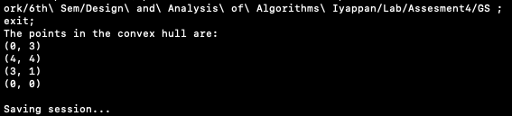

Time complexity Analysis:

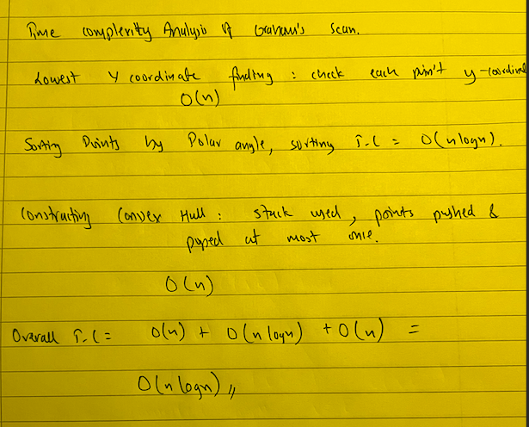

b. Jarvis March

Algorithm

FUNCTION orientation(p, q, r):

val = (q.y - p.y) * (r.x - q.x) - (q.x - p.x) * (r.y - q.y)

IF val == 0:

RETURN 0

ELSE IF val > 0:

RETURN 1

ELSE:

RETURN 2

FUNCTION convexHull(points[], n):

IF n < 3:

RETURN

INITIALIZE hull

FIND leftmost point l

p = l

REPEAT:

ADD points[p] to hull

q = (p + 1) % n

FOR i = 0 TO n-1:

IF orientation(points[p], points[i], points[q]) == 2:

q = i

p = q

UNTIL p == l

FOR each point in hull:

PRINT point

Code

#include <iostream>

#include <vector>

using namespace std;

struct Point {

int x, y;

};

int orientation(Point p, Point q, Point r) {

int val = (q.y - p.y) * (r.x - q.x) - (q.x - p.x) * (r.y - q.y);

if (val == 0) return 0;

return (val > 0) ? 1 : 2;

}

void convexHull(Point points[], int n) {

if (n < 3) return;

vector<Point> hull;

int l = 0;

for (int i = 1; i < n; i++)

if (points[i].x < points[l].x)

l = i;

int p = l, q;

do {

hull.push_back(points[p]);

q = (p + 1) % n;

for (int i = 0; i < n; i++)

if (orientation(points[p], points[i], points[q]) == 2)

q = i;

p = q;

} while (p != l);

for (int i = 0; i < hull.size(); i++)

cout << "(" << hull[i].x << ", " << hull[i].y << ")\n";

}

int main() {

Point points[] = { { 0, 3 }, { 1, 1 }, { 2, 2 }, { 4, 4 }, { 0, 0 },

{ 1, 2 }, { 3, 1 }, { 3, 3 } };

int n = sizeof(points) / sizeof(points[0]);

convexHull(points, n);

return 0;

}

Input

Point points[] = { { 0, 3 }, { 1, 1 }, { 2, 2 }, { 4, 4 }, { 0, 0 },

{ 1, 2 }, { 3, 1 }, { 3, 3 } };

Output

Time complexity analysis

